4.7.0 Design
The purpose of this section is to show a basic overview of the significant stages of the processes of the app and website.
As discussed above, all the data for both website and app are hosted on an SQL server. This means that data is easily shared at real time between website and app. Therefore, if a user were to create an account on the app, the same account can be used on the website within minutes of the account being created.
To link the SQL server to the app, a local SQLite database is hosted the app. Data is pushed and pulled to the local database using PHP. A similar method is used for the website, although there is no need for a local database for the website as it will be hosted on the same server as the SQL data. Below is a diagram representing the flow of data between server, app and website.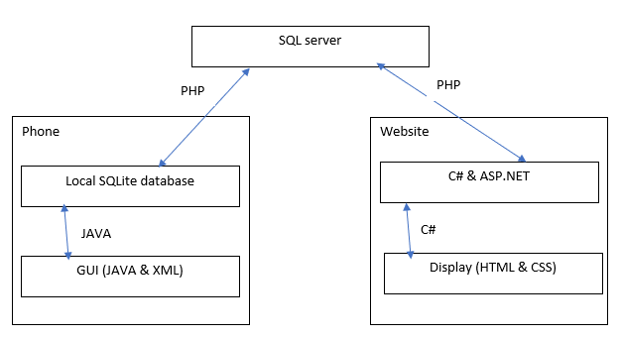
4.7.1 App
The app provides various services, this is managed through five main pages.
- A home page, where the user can navigate to other pages
- A contact page, where the contact details can be found
- A settings page, where the settings are displayed
  - Currently settings include, changing the apps theme
- An account page, where the user signs in/up
- A forums page, displaying all the posts
  - Here an option to create a post is available
  - An individual post can be clicked on taking the user to a post specific page, displaying all the replies to a post. Here the option to reply to a post will be available.

To deal with pulling and pushing to the SQL server, the class databaseHelper was made. This class acts as the local SQLite database, containing a multitude of functions required by the app. Each page creates an instance of an object of the class databaseHelper.
The databaseHelper class contains many functions including:
Constructors and creation
- A constructor
- OnCreate() which creates the local tables to be loaded into by the pulled data.
- onUpgrade() this removes previous data locally stored to allow new data
- refreshDatabase() Creates the tables required then calls the getData thread to populate the tables form the SQL server
Query functions
Each of these functions runs a query on the local SQLite database and returns the resulting information
- checkPopulated() returns a Boolean value depending if the local database is populated with data
- numberOfPosts() runs an SQLite query returning the number of posts in the local database.
- usernameExists() checks where a username exists in the local database, returning a Boolean value
- getPost() retrives a post with a given id passed through the functions parameters
- getPostInfo() retrives all the information relating to a postID passed through the functions parameters
Data manipulation functions
Each of these functions take a Boolean parameter determine whether to add the input information to the local database or the SQL server as well by running the uploadToDb thread.
- addContact() adds a contact to the local database and/or SQL server
- addPost() adds a post to the local database and/or SQL server
- addPostInfo() adds the postInfo data to the local database and/or SQL server
Threads
- getData thread
  - Runs php retriving data from the SQL server loading it into the local database
- UploadToDb thread
  - Uploads the local data to the SQL server using PHP.
Each time a page that uses the databaseHelper data is used the databaseHelper.refresh() function is called. This pulls all the information from the SQL server into the local database so that it can be manipulated by the page depending on what is required. A page attempts to retrieve the SQL server information once every 1.5 seconds. If the information is not retrieved after 3 attempts an error is displayed using androids built in toast function.
Thanks to the databaseHelper class, retrieving and pushing information from pages is a simple as calling a certain function. For instance the forums page’s post listView object is simply populated using an arrayAdapter Class filled by the databaseHelper.getPost() function.
4.7.2
Using normal HTML using ASP.net with C# back end, development of the websites functionality is simpler than that of the apps. The IDE Visual Studio will be used to develop the website code, once complete the code will be added to the server alongside the SQL and PHP files. Pushing and pulling the data will use a simplified version of the JAVA databaseHelper but developed in C#.
As for the layout of the website, a similar format to the app has been chosen.
TALK ABOUT WEBSITE LAYOUT.
END.

